- 52 52 Broadway, 18th Floor, New York, NY 10004
The UFT Teacher Center National
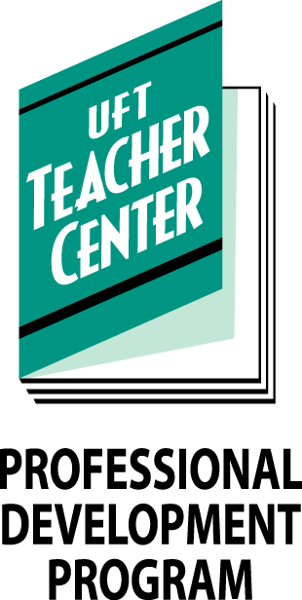
National Board Support Program

September 2, 2019

Support Sessions for Candidates 2019-2020
Candidate Support Sessions at the UFT Manhattan Borough Office:

Saturday September 14th, 2019, 9:00 AM - 3:00 PM;
52 Broadway 19th Floor, Rm H (Unpacking Component Two)

Saturday Sep 21, 2019, 9:00 AM - 3:00 PM; 50 Broadway
2nd Floor, Room EF (Unpacking Component Three)

Saturday Oct 5, 2019, 10:00 AM - 2:00 PM; 52 Broadway
19th Floor, Room A (Unpacking Component Four)

Thursday Oct 17, 2019, 5:00 PM - 7:00 PM; 50 Broadway
2nd Floor, Room C
Saturday Nov 2, 2019, 10:00 AM - 2:00 PM; 52 Broadway
19th Floor, Room A
Saturday Dec 7, 2019, 10:00 AM - 2:00 PM; 50 Broadway
12th Floor, Room #2
Thursday Dec 19, 2019, 5:00 PM - 7:00 PM; 52 Broadway
19th Floor, Room H
Saturday Jan 4, 2020, 10:00 AM - 2:00 PM; 52 Broadway
19th Floor, Room A

Thursday Jan 16, 2020, 5:00 PM - 7:00 PM; 52 Broadway
19th Floor, Room H
Saturday Feb 1, 2020, 10:00 AM - 2:00 PM; 50 Broadway
2nd Floor, Room EF
Thursday Feb 13, 2020, 5:00 PM - 7:00 PM; 52 Broadway
19th Floor, Room H
Saturday Mar 7, 2020, 10:00 AM - 2:00 PM; 50 Broadway
2nd Floor, Room D
Thursday Mar 26, 2020, 5:00 PM - 7:00 PM; 52 Broadway
19th Floor, Room A
Saturday Apr 4, 2020, 10:00 AM - 2:00 PM; 52 Broadway
19th Floor, Room H (Computer Exercises for Component 1)
Saturday Apr 25, 2020, 10:00 AM - 2:00 PM; 50 Broadway
2nd Floor, Room EF (Computer Exercises for Component 1)
Saturday May 2, 2020, 10:00 AM - 2:00 PM; 52 Broadway
19th Floor, Room A
Saturday May 9, 2020, 10:00 AM - 2:00 PM; 50 Broadway
2nd Floor, Room EF
Saturday May 23, 2020, 10:00 AM - 2:00 PM; 52 Broadway
19th Floor, Room A (Preparing for Component 1)

