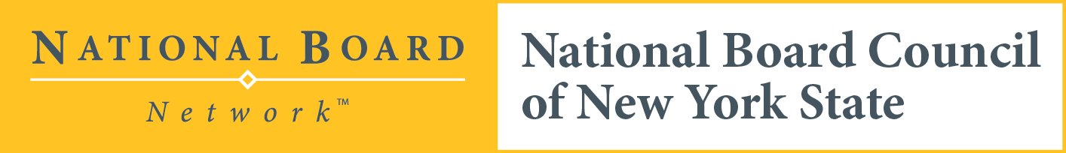

| **Consider the next step in your Professional Journey Join us for   Exploring the National Board Certification Process- An Awareness Webinar**   This Awareness Session is an opportunity for educators to virtually connect and discuss the process of becoming a **National Board Certified Teacher.**  An overview of components of process, resources, and  time for Q &A will be provided.  **Am I eligible?** Do you have a NYS Teacher Certification?  Do you have 3 years of teaching experience?  **Date:** May 20th, 2020 **Time:** 4pm **NBCT Facilitators**: Sarah Duke and Colleen Napora **Cost:** Free-Please register for a CTLE certificate  **Registration**: <https://forms.gle/yovUEP6a7JTK8pq49>  **Sponsored by**: NBCNY  **Additional Information:**   * <http://www.nbpts.org> * <http://www.nbcny.org> * [Colleen Napora](mailto:ruirish01@gmail.com), NBCT |
| --- |
|  |