National Board Candidates Writing Retreats

Please join us at Nazareth College in the Golisano Academic Building rooms 51 and 53(*) to work on your components. Please bring your laptop, earbuds, NBPTS Standards, portfolio directions and feel free to dress comfortably. Breakfast and lunch will be provided!
*Note room change*

Retreat 1 | Retreat 2
February 7th: 4-8 p.m. | March 27th 4-8 p.m.
February 8th: 9 a.m.-4 p.m. | March 28th 9 a.m.-4 p.m.

Please RSVP by February 1st for Retreat 1. Please contact Caron.Lindstrom@gmail.com if needed.

Sponsored by:
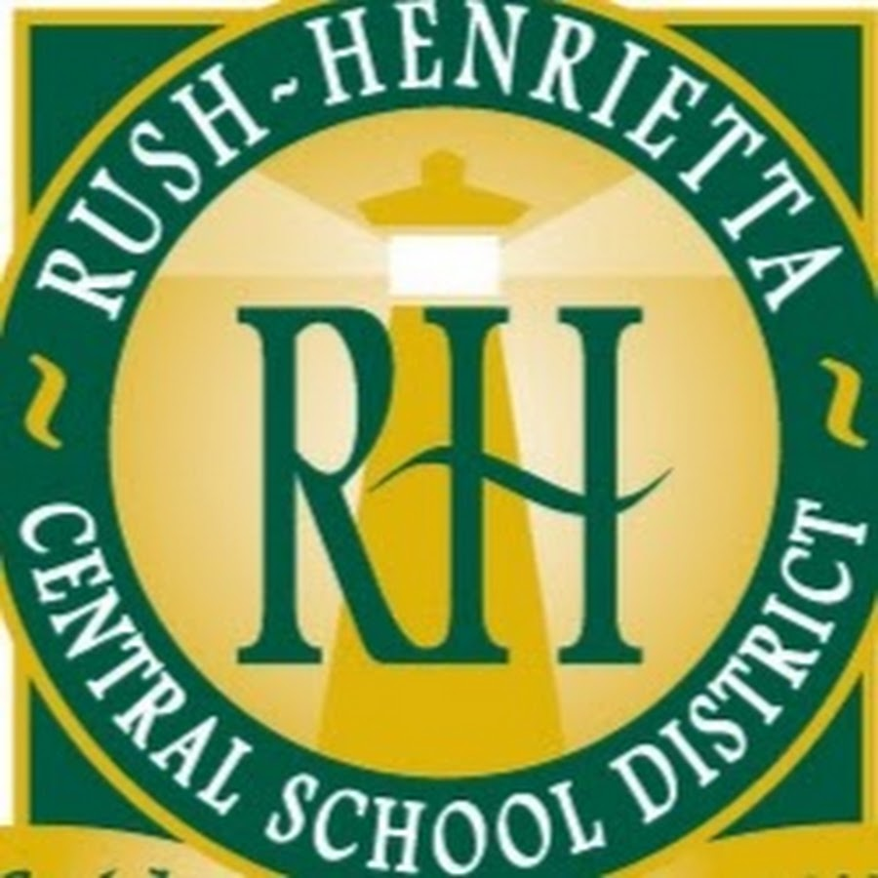
Teacher Center
Additional Information on NBC, graduate credit and more:
- National Board for Professional Teaching Standards
- National Board Council of New York
- NYSUT ELT

